Kindly research and if possible try to use the Jupyter Notebook:

Strings

▪ Creating a String

▪ Accessing Characters in the String

▪ Removing Space from a String

▪ Python String Methods

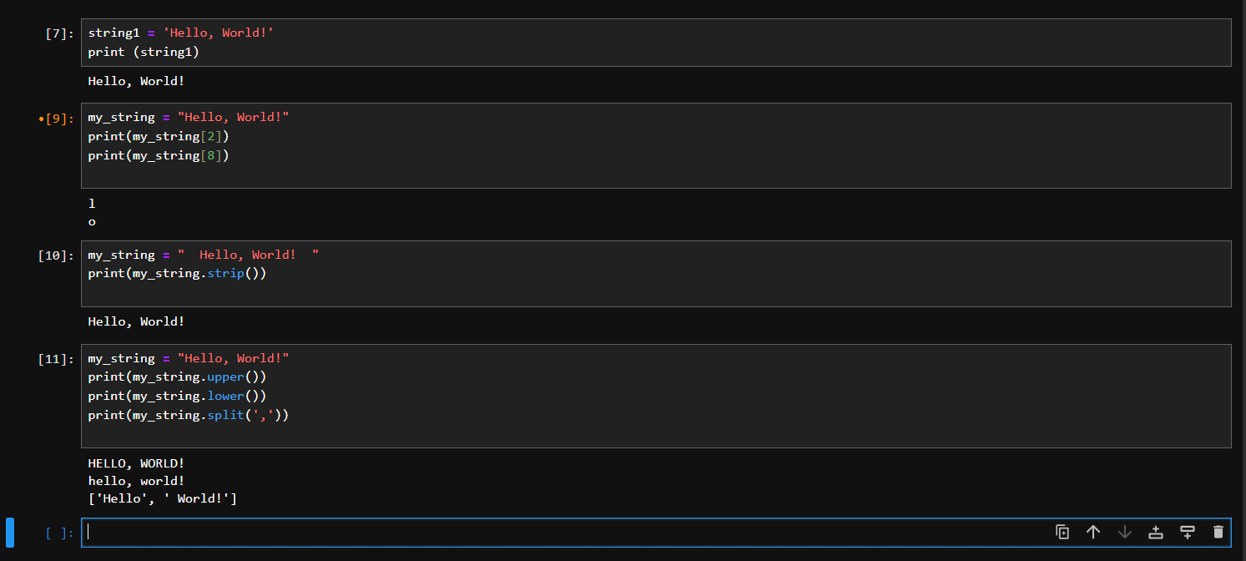

**Python and jupyter notebook**

● Launch Jupyter Notebook

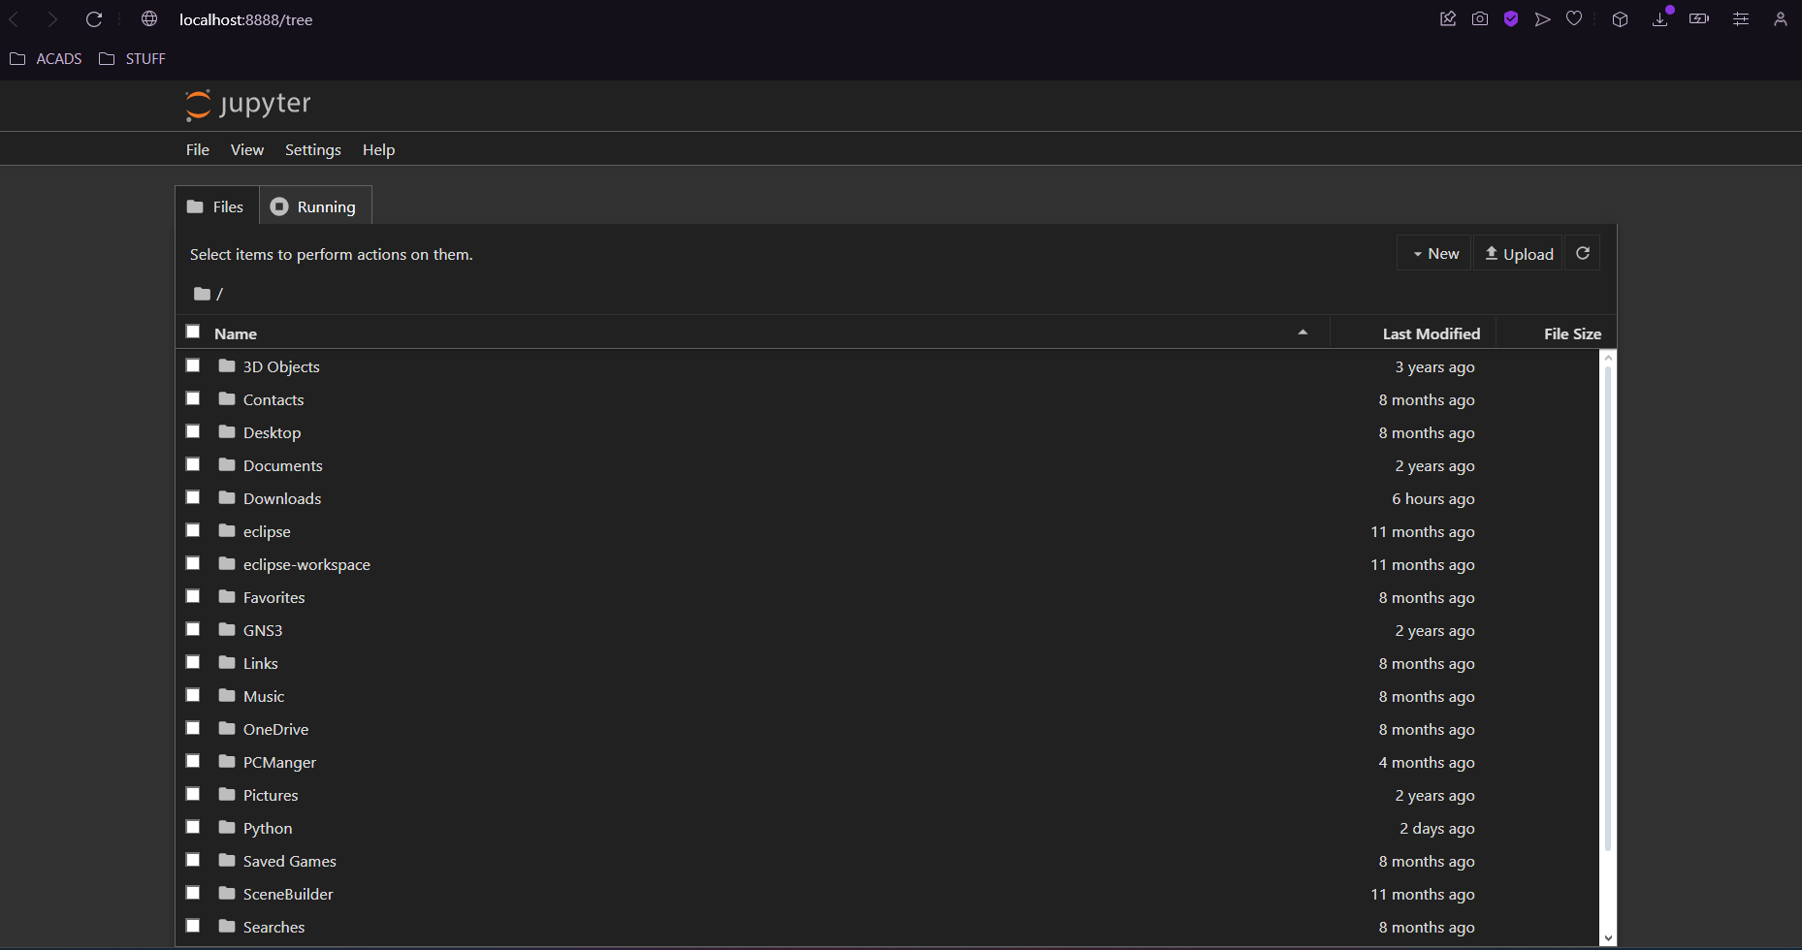

● Open a notebook file

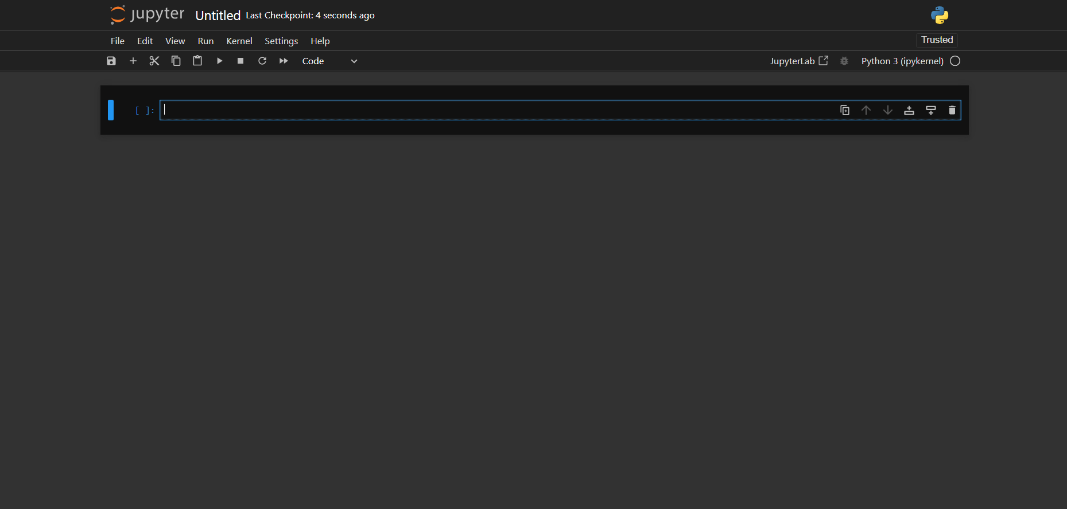

● Launch Jupyter Notebook



● Start writing a Jupyter Notebook

